TOLL PLAZA

k.sobhan

RA2111003011022

SECTION :D2

#include <stdio.h>

#include <conio.h>

#include <math.h>

int main()

{

int choice;

int r;

printf("########################################################################################################################\n");

printf(" \t\t\t ***WELCOME***\n");

printf(" \t\t\t***KADAPA TOLL PLAZA***\n");

printf(" \t VECHILE TYPE SINGLE TRIP MONTHLY PASS WITHIN THE DISTRICT\n");

printf(" \t (Per VECHILE) (Per VECHILE)\n");

printf(" \t CAR/JEEP Rs.100 Rs.200\n");

printf(" \t BUS/LORRY Rs.90 Rs.150\n");

printf(" \t CONTAINERS Rs.120 Rs.300\n");

printf(" \t LCV Rs.100 Rs.200\n");

printf("########################################################################################################################\n");

for(int i=1;i<=100;i++)

{

printf("Select Your Choice\n");

printf("1.SINGLE TRIP");

printf("\n2.MONTHLY PASS WITHIN THE DISTRICT");

printf("\nyour choice :");

scanf("%d",&choice);

switch(choice)

{

case 1:{

printf("ENTER VECHILE TYPE : ");

scanf("%d",&r);

if(r==1)

{

printf("Total Cost for Single trip in CAR/JEEP =Rs.100\n\n");

}

else if(r==2)

{

printf("Total Cost for Single trip in BUS/LORRY=Rs.90\n\n");

}

else if(r==3)

{

printf("Total Cost for Single trip in CONTAINERS=Rs.120\n\n");

}

else if(r==4)

{

printf("Total Cost for Single trip in LCV=Rs.100\n\n");

}

break;

}

case 2:{

printf("\nENTER VECHILE TYPE : ");

scanf("%d",&r);

if(r==1)

{

printf("Total Cost for Monthly pass within the district for CAR/JEEP=Rs.200\n\n");

}

else if(r==2)

{

printf("Total Cost for Monthly pass within the district for BUS/LORRY=Rs.150\n\n");

}

else if(r==3)

{

printf("Total Cost for Monthly pass within the district for CONTAINERS=Rs.300\n\n");

}

else if(r==4)

{

printf("Total Cost for Monthly pass within the district for LCV=Rs.200\n\n");

}

break;

}

getch();

}}}

Code Screenshots

SCREEN SHOT-1

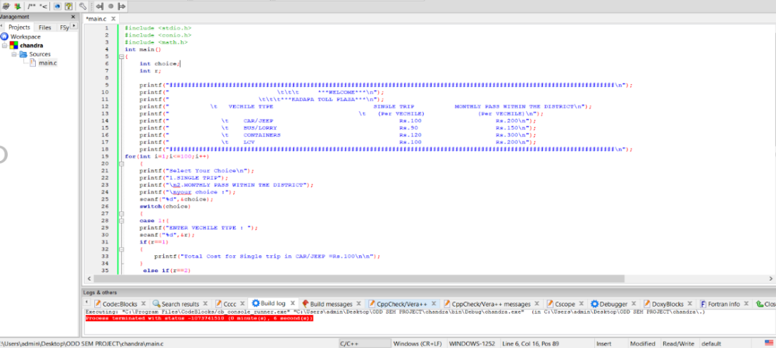

SCREEN SHOT-2

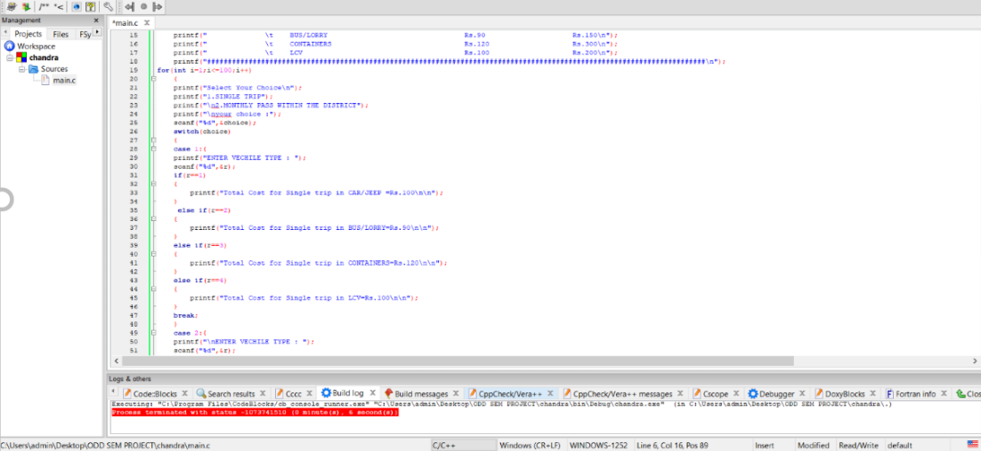

SCREEN SHOT-3



**SAMPLE OUTPUTS**

